# Dependency Inversion Principle

A. High-level modules should not depend on low-level modules. Both should depend on abstractions.

B. Abstractions should not depend on details. Details should depend on abstractions.

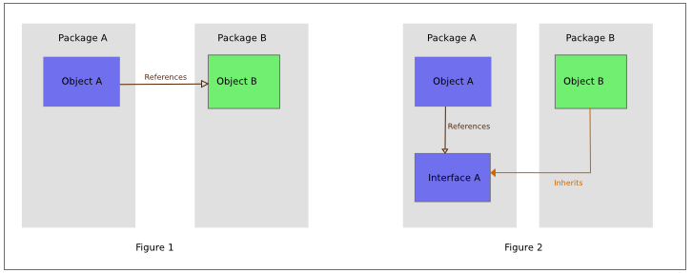

Source: <https://en.wikipedia.org/wiki/Dependency_inversion_principle>

## Code for the exercise:

Example in Java:

<https://github.com/xebia-france/geocoder-kata>

Example in C#:

<https://github.com/ernst-fastl/geocoder-kata-csharp>